**DWC**

*By belonging and working to have an active home club, you are an integral part of a nation of dynamic, progressive women who make a difference in our government and political system.*

*\*\*\**

*The Democratic Women's Club of Palm Bay was chartered on May 5, 1990.*

*The objectives of the club shall be:*

*\* To bring together in common purpose all Democratic women and men in Palm Bay.*

*\* To organize the registered Democratic voters of Palm Bay.*

*\*To study the principles of the Democratic Party and support its candidates.*

*\*To Encourage good citizenship by stimulating interest in civic affairs.*

**DWC**

*\* Educate the electorate on questions of public interest.*

*\* Take an active interest in the welfare of our community, Country, and State.*

*\* Encourage the participation of Voters in politics*

*\* To support qualified Democratic candidates for public office and to encourage qualified Democrats to seek elected office.*

*\*To seek increased voter registration and participation.*

*\*To encourage every registered Democrat to vote.*

*Rev. 7/2024*

***New Member Application***

*Date: ____________________________*

*Name:___________________________*

*Address:__________________________*

*City:_____________________________*

*State:___________ Zip:_____________*

*Home phone:______________________*

*Cell:_____________________________*

*E-mail:___________________________*

*Occupation:_______________________*

*Date of Birth: (mm/dd):_______________*

*Voter Registration#:__________________*

*Precinct: _______________________*

*Signature:___________________________*

*Referred By:_________________________*

***YEARLY MEMBERSHIP  
 FEE: $25.00  
 Make checks payable to:  
 DWC of Palm Bay*** *I am interested in the following (circle):  
 Fundraising Awards/Scholarship  
 Political Voter Education  
 Hospitality Membership  
 By-Laws*

_______________________

Democratic Women's Club

of Palm Bay

P.O. Box 100304

Palm Bay, FL 32910

Email: dwcpb.win@gmail.com

President

Kathryn Bull

845-649-5664

*To learn more about the Florida Democratic Party, issues important to the lives of women/men and ways to overcome the challenges facing Brevard County, join the Palm Bay Democratic Women's Club today, your gateway to the Florida Democratic Party*

MEMBERSHIP HAS Its PRIVILEGES

*

Regular monthly meetings with special guests

*

Quarterly newsletter with events calendar

*

Fellowship with like-minded women and men

*

Part of the second largest Democratic Women's Clubs Region in Florida

Visit us on the Web at:

www.democraticwomensclubofpalmbay.com

***Democratic Women's Club***

***Of***

***Palm Bay***

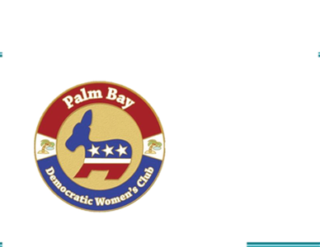

**Membership**

**Application**

**Your Gateway To**

**Florida's Democracy**